**Problem Statement 01:**

| $> hdfs dfs -mkdir /user/$USER/bhavithan/dir01  $> hdfs dfs -put input1.txt /user/$USER/bhavithan/dir01  $> hdfs dfs -copyFromLocal input2.txt /user/$USER/bhavithan/dir01  $> hdfs dfs -put input3.txt /user/$USER/bhavithan/dir01 |
| --- |

1. Create a folder in HDFS by name “dir01” and move input1.txt , input2.txt and input3.txt into /dir01.2. List only the file names present in “/dir01”

| $> hdfs dfs -ls /user/$USER/bhavithan/dir01 |
| --- |

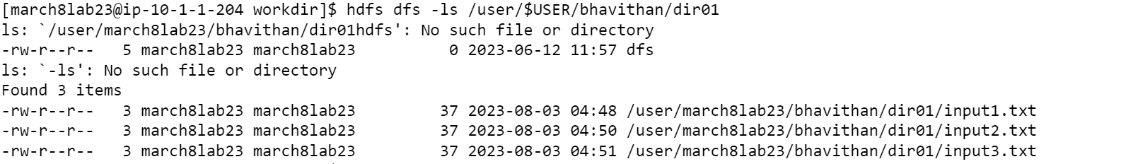

3. Change the replication factor for the content present in directory “/dir01” to 5 and display the replication factor for the files present in “/dir01”.

| $> hdfs dfs -setrep 5 /user/$USER/bhavithan/dir01  $> hdfs dfs -ls /user/$USER/bhavithan/dir01 |
| --- |

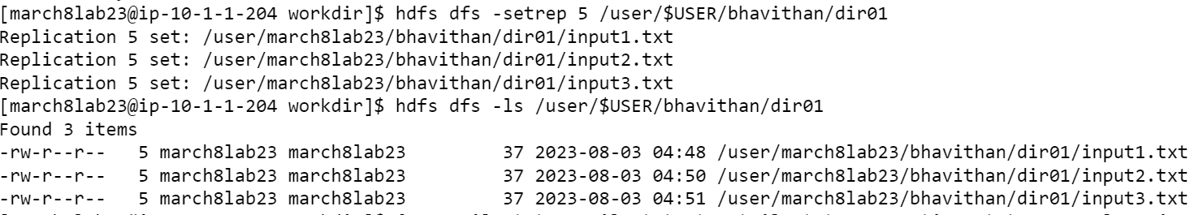

4. Create a folder in HDFS by name **“scenario01”** and create directory **“level01” inside “scenario01”** directory and create another directory **“level02” inside directory “level01”**. Once the required directories are created **copy input1.txt to scenario01**, **input2.txt to level01** and **input3.txt to level02** and finally recursively print only the file names present in directory scenario01

| $> hdfs dfs -mkdir /user/$USER/bhavithan/scenario01  $> hdfs dfs -mkdir /user/$USER/bhavithan/scenario01/level01  $> hdfs dfs -mkdir /user/$USER/bhavithan/scenario01/level01/level02  $> hdfs dfs -cp /user/$USER/bhavithan/dir01/input1.txt /user/$USER/bhavithan/scenario01  $> hdfs dfs -cp /user/$USER/bhavithan/dir01/input2.txt /user/$USER/bhavithan/scenario01/level01  $> hdfs dfs -cp /user/$USER/bhavithan/dir01/input3.txt /user/$USER/bhavithan/scenario01/level01/level02  $> hdfs dfs -ls -R /user/$USER/bhavithan/scenario01/ |
| --- |

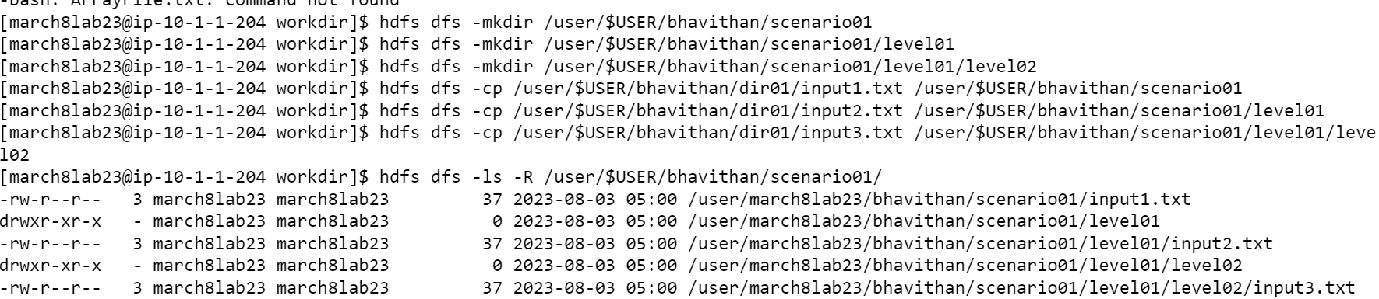

**Problem Statement 02:**

1. **Run MapReduce Program and capture the application Id of the job.**

Command:

yarn jar hadoop-mapreduce-examples-3.0.0-cdh6.2.1.jar wordcount /user/$USER/bhavithan/ /user/$USER/bhavithan/outpur_dir

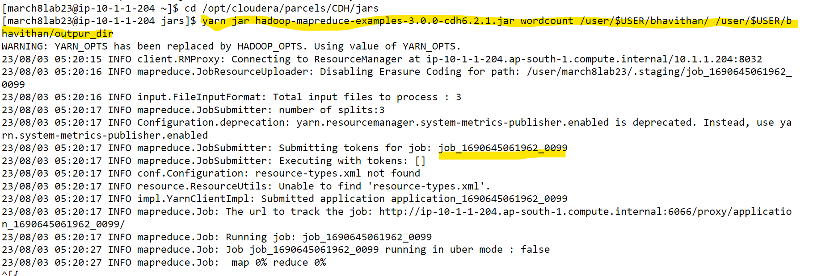

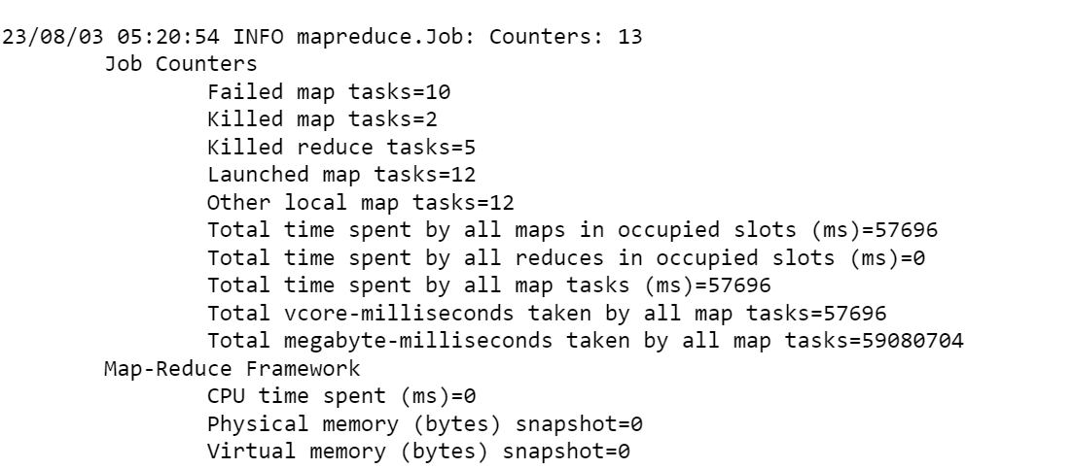

**2. Re-run the MapReduce program and kill the application using the yarn command.**

Command:

yarn application -kill

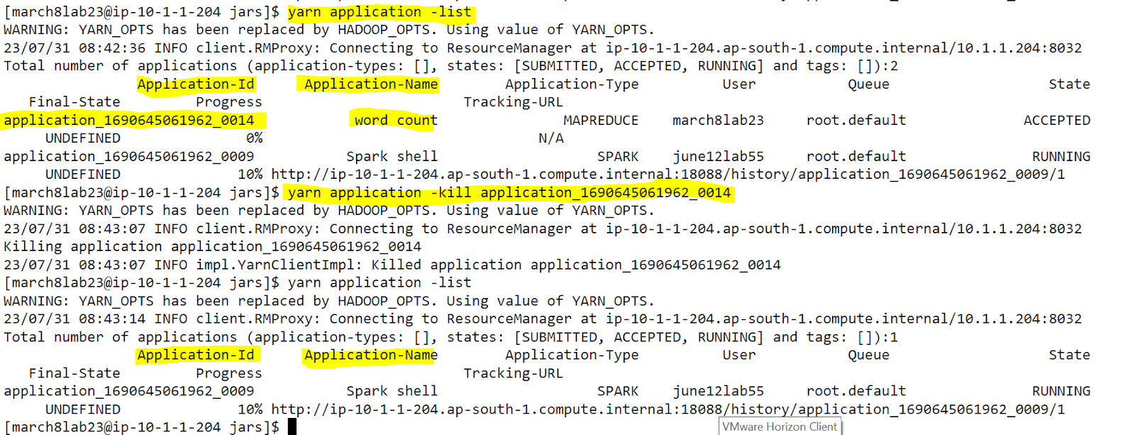

**3. List all the applications which are RUNNING state**

Command:

yarn application -list

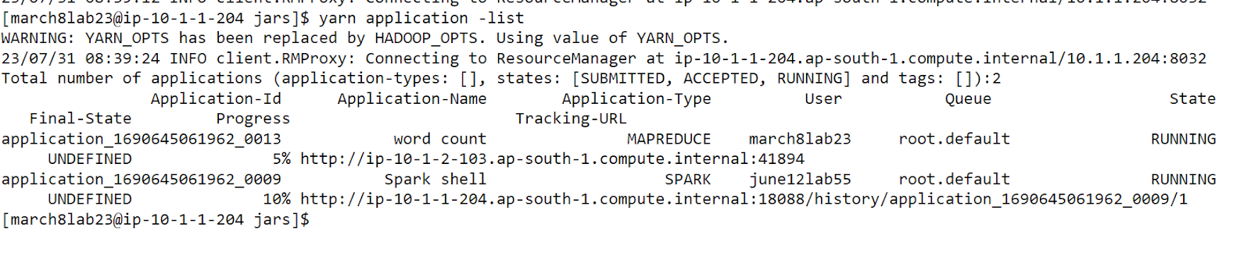

**4. View the logs of any of the jobs which are already completed.**

Command:

yarn logs -applicationId application_1690645061962_0014

